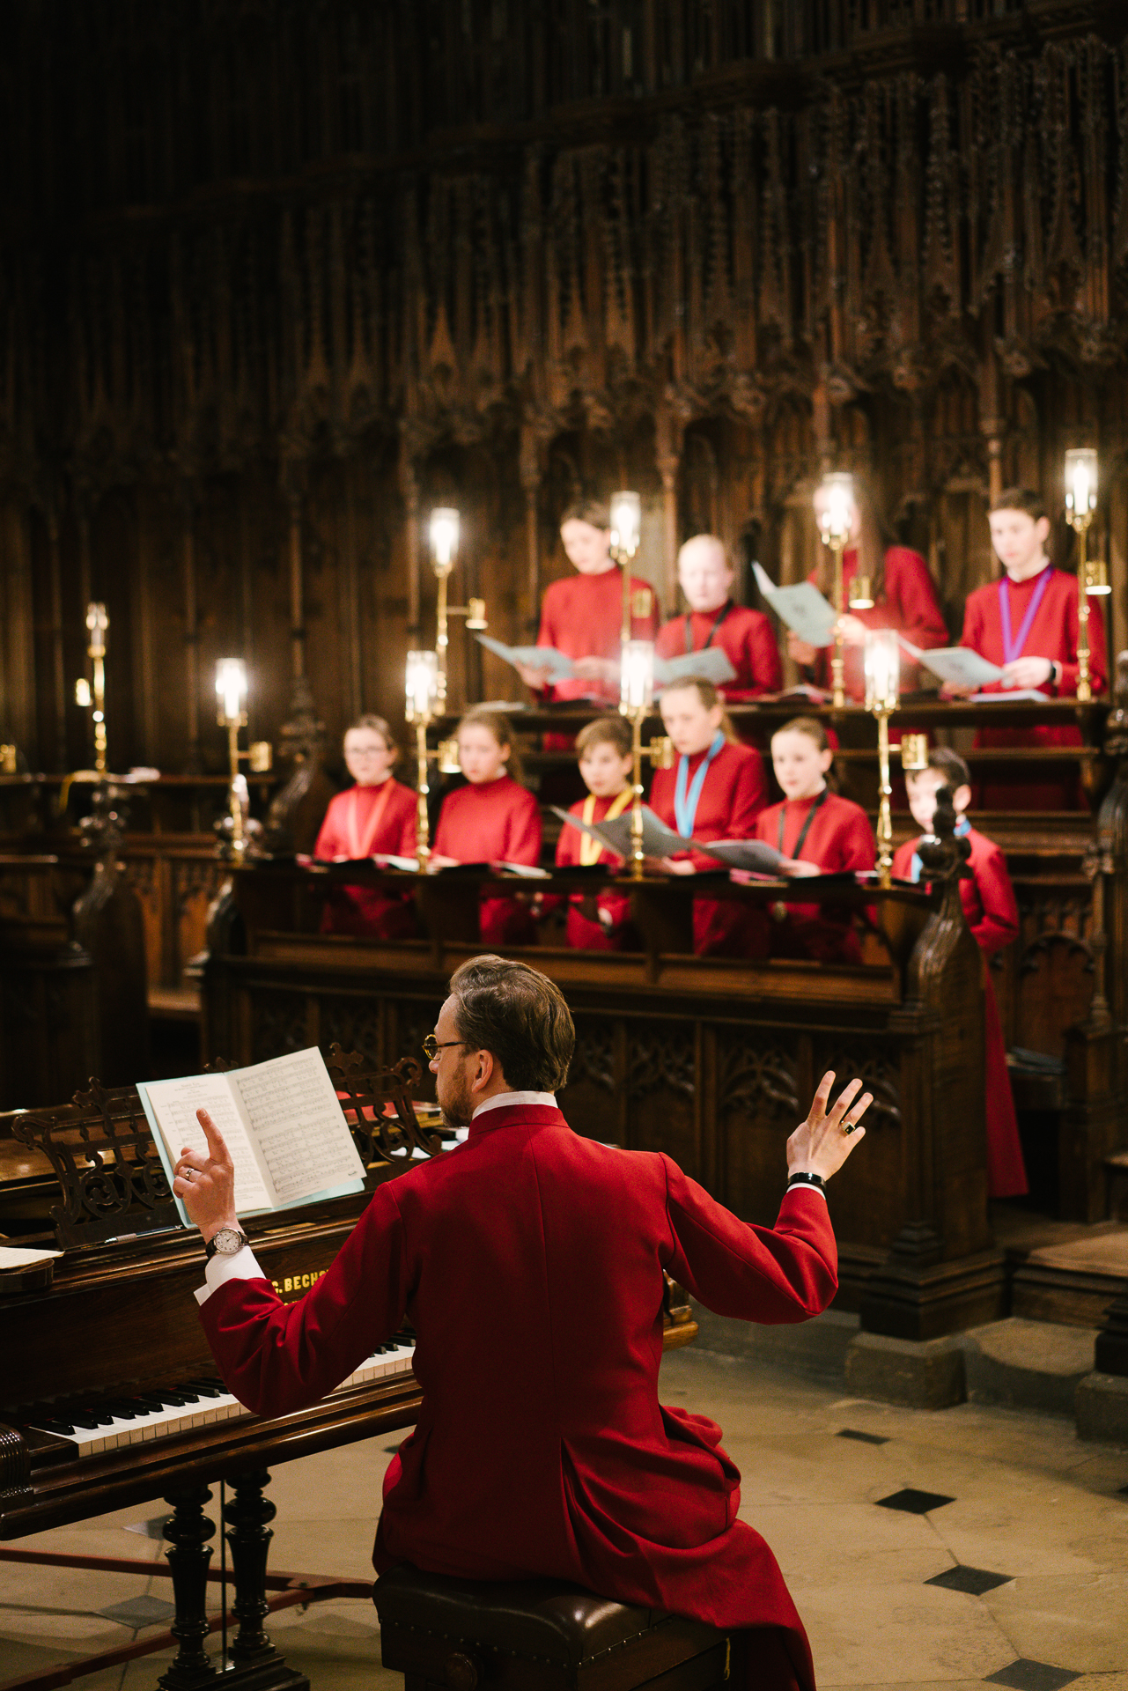
Chorister Supervisor
(Girls)


JOB DESCRIPTION FOR THE POST OF
Chorister Supervisor (Girls)

VISION AND STRATEGY
Growing God’s Kingdom is the vision and strategy of the Chapter of Ripon Cathedral. Jesus’ own teaching and ministry show that the kingdom was central to his mission, as does his instruction to pray for its coming on earth as in heaven. It is clear that this includes promoting fullness of life for all people. As Jesus said, according to St. John, ‘I came that they may have life, and have it in its fullness’.

The Cathedral takes the safety of everyone within the Cathedral very seriously and expects that everyone will work within the cathedral’s safeguarding policy. In particular, the Cathedral expects anyone who becomes aware of a safeguarding risk or of actual abuse, to report it immediately in accordance with the cathedral’s safeguarding procedures.

PURPOSE & TERMS OF REFERENCE
The safety, welfare and happiness of our young people is of paramount importance to the Cathedral Chapter. The purpose of this role is to contribute to the mission and ministry of Ripon Cathedral by providing support and assistance to the Music staff in the care and welfare of the Cathedral choristers and choral scholars.

The person appointed will be employed by the Cathedral Chapter, on whose behalf the Chief Operating Officer provides overall management for all contracted employees.

The Line Manager for this post will be the Director of Music.

This post is subject to an Enhanced DBS Declaration.

This post may be available as a job share for complementary candidates.

TERMS & CONDITIONS
The Chorister Supervisor (Girls) will be expected to work an average of 24.5 hours per fortnight term-time only. The regular pattern of working hours is listed under “Required Hours”.

Some flexibility with working hours will be required. Occasional attendance at events in unsocial hours, such as concerts or special service in the Cathedral and at other venues, will be expected and hours can be negotiated as required.

CONTEXT
The Music Department is led by the Director of Music who is managed by the Canon Precentor. The Chorister Supervisor for the girls will work collaboratively within the music team, and with parents and children to maintain a safe and secure environment in order to deliver and develop the music as an integral part of the life of the Cathedral within the direction of the strategy set by Chapter.
To support the Cathedral’s safeguarding measures, when boy and girl choristers and choral scholars are present at the same time, it is usual for a Chorister Supervisor for the boys to be also on duty.

The post of Chorister Supervisor is located within Ripon Cathedral, which is a place of Christian Worship and Mission within the Church of England. The person appointed will be expected to respond positively to this ethos
The Music Department comprises (in addition to the Chorister Supervisor [Boys] and
Chorister Supervisor [Girls]):

Canon Precentor The Revd Canon Michael Gisbourne
Director of Music Dr Ronny Krippner
Assistant Director of Music Tim Harper
Assistant Organist Alastair Stone
Chorister Vocal Coach Matt Lennox
Music and Liturgy Administrator Laura Jones

MAIN DUTIES AND RESPONSIBILITIES

GENERAL
- To attend all rehearsals, services and other activities as required and agreed.

- Together with other members of the Music Department, to provide supervision and care of the choristers and choral scholars.

- To work as part of the Staff team, developing a good working relationship with all Cathedral Staff attending meetings as required.

- To attend the weekly Music Department meeting (currently Tuesdays at 11am) as arranged.

- To attend the Choristers’ Forum which meets each term.

PASTORAL
- To be the principal carer for the choristers, providing initial medical and pastoral support, administering medicine and basic first aid as permitted and required.
- To provide refreshments for the choristers during breaks.
- To appropriately supervise toilet visits.
- To keep up-to-date with relevant first-aid training and ensure first-aid kits are present and up-to-date in all rehearsal spaces.
- To follow-up unexplained chorister/choral scholar absence and to enter details on the child’s record.
- To assist the choristers/choral scholars with robing and ensure that they are smart and tidy.
- To keep close at hand appropriate records of the choristers'/choral scholars’ health and special needs and to be fully involved in discussions relating to any special requirements.

- To keep appropriate members of staff notified of any concerns regarding specific children or health and safety in general (with the guidance of the Cathedral or Diocesan Safeguarding Officer if appropriate).

REQUIRED HOURS
Mondays (fortnightly), Tuesdays, Wednesdays, Fridays during Choir Term (weekly)
0725 – 0845 Chorister rehearsal (quire – Wed, Fri)
chorister handover from parents
supervision before rehearsal
taking register and following up on unauthorised absences
attendance during rehearsal
chorister handover to parents (where appropriate)
1100 – 1200 Weekly Music Department Meeting (Music Dept Office – Tuesday, fortnightly)
1555 – 1830 Chorister Rehearsal / Choral Evensong
(Cathedral Hall or Cathedral – Mon fortnightly, Wed, Fri)
chorister handover from parents
supervision before rehearsal
taking register and following up on unauthorised absences
attendance during rehearsal and service
chorister handover to parents (where appropriate)

Sunday during Choir Term (fortnightly)
0855 – 1145 Chorister rehearsal and Sung Eucharist (Library and Cathedral Nave)
chorister handover from parents
supervision before rehearsal
attendance during rehearsal and service
chorister handover to parents (where appropriate)
1355 – 1645 Chorister rehearsal and Choral Evensong (Library and Cathedral Nave)
chorister handover from parents
supervision before rehearsal
attendance during rehearsal and service
chorister handover to parents (where appropriate)

ADMINISTRATION AND COMMUNICATION
- To ensure the register for each chorister/choral scholar event is kept accurately, and to administer the signing-out procedure diligently at the end of chorister/choral scholar events.
- To follow-up with parents/guardians immediately if a chorister/choral scholar is absent unexcused.
- To develop a knowledge and understanding of the Cathedral safeguarding procedures, including confidentiality.
- To work as part of the Staff team, developing a good working relationship with all Cathedral Staff and attending meetings as required.
- To ensure that appropriate notes are made regarding incidents/administration of medication that may happen while the choristers are in the care of the Cathedral.
- To keep close at hand a list of emergency phone numbers for choristers/choral scholars.

- To contact parents/guardians if it is judged that a child is sufficiently unwell to continue with a rehearsal or service.

- To oversee maintenance of choir robes with others, including co-ordination of regular cleaning, repairs and fitting for choristers and choral scholars as required.

- To help with logistics of choir visits and choir tours.

COMPLIANCE
- To work with their colleagues to make sure that the Cathedral’s Safeguarding Policy is observed at all times and reporting immediately any concerns or issues that threaten the safety or welfare of any child or person within the care of the Cathedral.
- To ensure that all work and activities are undertaken in compliance with applicable statutes, regulations and directives regarding Health & Safety, Fire and Security, GDPR, including the Cathedral’s internal policies and procedures.
- To take reasonable care for the health and safety of themselves and of others who may be affected by their acts or omissions at work.
- This post will require an Enhanced DBS check.

In addition, all employees are expected to work within the terms of their Contract of Employment and adhere to the Cathedral’s policies and practices.

Occasionally situations may arise that require the post holder to perform other duties and tasks as may be reasonably requested by the chapter of the Cathedral.

PERSON SPECIFICATION

- Experience working with children, particularly in a pastoral role

- Commitment to the well-being of all choristers/choral scholars, to include:
- The ability to recognise unusual behaviours
- Supporting attentiveness and good behaviour
- caring for choristers/choral scholars when they are unwell or distressed

- Good communication skills with both children and adults

- Commitments to supporting the discipline and ethos of the Cathedral and its music

- Knowledge of and sympathy towards the services and worship of the Church of England

- Good computer skills

- Self-motivated and organised

- Qualified in giving First Aid or willing to be trained as part of the induction of the role

